|  |  |
| --- | --- |
| **WC Logo.emf** | **Staff Report to the Weber County Commission**  *Weber County Planning Division* |
|  | |

****Synopsis****

****Application Information****

**Application Request:** Request for final approval of Mountainside Phase 2 PRUD Subdivision, consisting of ten lots in the RE-15 zone, located at approximately 4554 N Seven Bridges Rd, Eden, UT, 84310.

**Type of Decision: Administrative**

**Agenda Date: Tuesday, June 27, 2023**

**Applicant: John Lewis, Owner**

**File Number:** UVM080922

****Property Information****

**Approximate Address:** 4554 N Seven Bridges Rd, Eden, UT, 84310

**Project Area:** 3.797 acres

**Zoning:** Residential Estates (RE-15) Zone

**Existing Land Use:** Vacant

**Proposed Land Use:** Residential

**Parcel ID:** 22-006-0004, 22-006-0039

**Township, Range, Section:** T7N, R1E, Section 15 SW, 16 SE

****Adjacent Land Use****

**North:** Vacant/The Grove Cabins site **South:** Mountainside PRUD Phase 1

**East:** Vacant/Mountainside PRUD additional phase site **West:** Vacant/ The Grove Cabins site

****Staff Information****

**Report Presenter: Tammy Aydelotte**

**taydelotte@webercountyutah.gov**

**Report Reviewer: SB**

Applicable Land Use Codes

* Weber County Land Use Code Title 106 (Subdivisions)
* Weber County Land Use Code Title 108 (Natural Hazard Areas)
* Weber County Land Use Code Title 104 (Zones) Chapter 3 (RE-15 Zone)

Background and Summary

7/19/2016 – Conditional Use Permit request for The Bridges PRUD was approved.

9/20/2017 – Mountainside PRUD Phase 1 recorded.

9/27/2022 – Preliminary approval granted by Ogden Valley Planning Commission.

11/29/2022 – Recommendation of final approval by Ogden Valley Planning Commission

The applicant is requesting final approval of Mountainside PRUD Phase 2 Subdivision, consisting of ten lots, in the RE-15 Zone. This proposal includes continuation of Seven Bridges Road as a public right-of-way. The proposed subdivision and lot configuration are in conformance with the applicable zoning and subdivision requirements as required by the Uniform Land Use Code of Weber County (LUC). The following is a brief synopsis of the review criteria and conformance with LUC.

Analysis

*General Plan:* The proposal conforms to the Ogden Valley General Plan by encouraging development within the existing resort-related areas.

*Zoning:* The subject property is located in the Residential Estate Zone more particularly described as the RE-15 zone.

The purpose and intent of the RE-15 zone is identified in the LUC §104-3-1 as:

*“The major purpose of the RE-15 and RE-20 Zones is to provide and protect residential development at a low density in a semi-agricultural or rural environment. It is also to provide for certain rural amenities on larger minimum lots, in conjunction with the primary residential nature of the zone.”*

As part of the subdivision process, the proposal has been reviewed against the current subdivision ordinance in LUC §106, the PRUD ordinance in LUC §108-5, and the applicable standards in the RE-15 zone (LUC §104-3) to ensure that the regulations and standards have been adhered to. The proposed subdivisions, with the recommended conditions listed in this staff report, are in conformance with county code. The following is a brief synopsis of the review criteria and conformance with the LUC.

*Lot area, frontage/width and yard regulations*: The proposed subdivision is one of four phases in the Mountainside community and has received conditional use approval for “The Bridges PRUD” development.

The purpose and intent of a Planned Residential Unit Development (PRUD) is intended to *“allow for diversification in the relationship of various uses and structures to their sites and to permit more flexibility of such sites and to encourage new and imaginative concepts in the design of neighborhood and housing projects in urbanizing areas”* (LUC§ 108-5-2).Mountainside Phase 2 PRUD utilizes the allowed flexibility with lots ranging in size from 10,000 square feet to 15,000 square feet, and lot widths ranging in size from approximately 82 feet to approximately 105 feet. The various lot sizes will allow for the future lot owners to build custom homes ranging from 2000 to 4000 square feet. The approved minimum single family yard setbacks for the PRUD are:

Front Yard: 15 feet

Side Yard: 7.5 feet

Side; facing street on corner lot: 15 feet

Rear Yard: 20 feet

Based on the allowed flexibility of a PRUD, the proposed layout, lot configurations and lot sizes are acceptable. In order to provide clear site standards, staff recommends adding the minimum setback standards on the final subdivision Mylar. A condition of approval has been added to staff’s recommendation to ensure the minimum setback standards are added to the final subdivision Mylar.

*Ogden Valley Sensitive Lands Overlay Districts*: The development area falls within an area identified as an “Important Wildlife Habitat Area” that is part of the Ogden Valley Sensitive Lands Overlay Districts (LUC§ 104-28). A note providing adequate notice of the Important Wildlife Habitat area and the development standards that are required will be added to the final subdivision Mylar.

*Natural Hazards Overlay Zone:* The proposed subdivision is located in a Zone “X” as determined by FEMA to be an area determined to be outside 500-year floodplain.

A geologic hazard study, performed by Western Geologic and dated 7/21/2022 is on file with Weber County. All recommendations outlined in this report shall be followed as further development continues.

*Culinary water, irrigation water and sanitary sewage disposal:* The applicant has provided a will-serve letter from the Wolf Creek Water and Sewer District for the culinary and irrigation water and sanitary sewer (see Exhibit B).

*Review Agencies:* The Weber County Surveyor’s Office, Weber County Engineer, and the Weber Fire District have reviewed the proposal and have provided the applicant with the additional items that will be required prior recording the final Mylar.

*Tax clearance:* The 2022 property taxes have been paid in full. The 2023 property taxes will be due in full on November 30, 2023.

Planning Commission Recommendation

Staff recommends final approval of Mountainside PRUD Phase 2 Subdivision, consisting of ten lots located at approximately 4554 N Seven Bridges Rd, Eden, UT, 84310. This recommendation is subject to all review agency requirements and the following conditions:

1. The dedication language on the final Mylar will need to include language to grant ownership of the common area to the applicable ownership.
2. In order to provide clear site standards, staff recommends adding the minimum yard setback standards on the final subdivision Mylar including the “Side; facing street on corner lot” setback.
3. A note providing adequate notice of the Important Wildlife Habitat area and the development standards that are required will be added to the final subdivision Mylar.
4. Prior to recording the final Mylar, all lots that are impacted by a geologic hazard will be identified on the final Mylar. A note shall be included on the final mylar to provide notice that the final geologic and geotechnical reports are on file with Weber County Planning Division. A “Natural Hazards Disclosure” document will be required to be recorded to provide adequate notice of any geotechnical and geological recommendations for future property owners.
5. If the applicant desires, a note will be added to the final Mylar to provide notice of the approved nightly rental option.

This recommendation is based on the following findings:

1. The proposed subdivision conforms to the Ogden Valley General Plan
2. The proposed subdivision complies with applicable county ordinances

Exhibits

1. Subdivision Plat

|  |
| --- |
|  |

****Area Map****

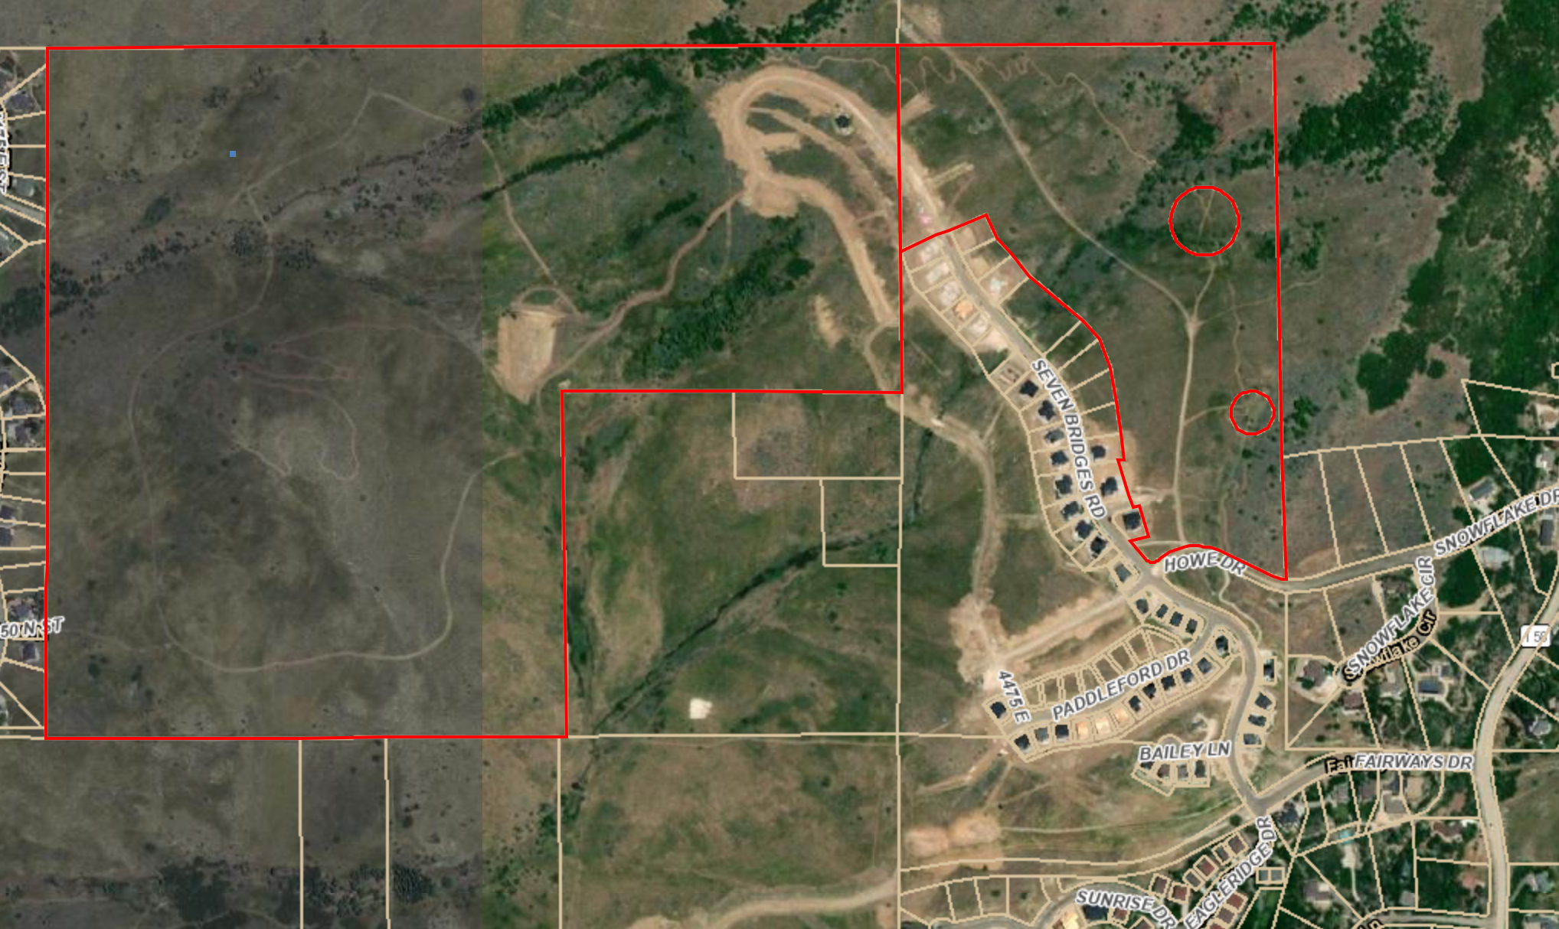

****Exhibit A– Subdivision Plat****

